# Name: Dylan Li

# Part 1: Economic Indicators

## Analysis

In this section, you should:

* Explain your data wrangling process (if any). Note down any important new columns you created in your BI tool and any steps you took to clean the data, change data types, etc.
* Explain your findings. Be sure to include answers to the questions:
  + How have GDP and Consumer Sentiment changed during the pandemic? What was the general trend before 2020 and how has it changed from 2020 onwards?
  + What are the limitations of using this data to try to understand how the pandemic has affected the economy?

The consumer sentiments data is missing, so I picked retail sales instead. Data type for GDP values were changed to currency, with no other changes made.

GDP value fluctuated with a recurring pattern quarterly, with a steady increase trend on a yearly basis. The first exception happened in 2008 when there was a recession in the US. By that time, US GDP decreased to below the trendline. The second exception happened by the beginning of Covid-19 Pandemic around January 2020, when GDP drastically decreased, but it rose back to normal by 2021.

Similar trend applied to retail sales. However, in 2020 retail sales only dropped a bit more than normal, which was followed by a large increase to even higher than the trendline by 2022. In a way the retail sales boost lifted GDP up.

The graph shows that, despite the overall drop of GDP amount, US people showed a high consumer sentiment during Covid-19 period. Though the limitation of the datasets is that we can only provide a descriptive analysis. There’s no correlation or causation can be approved here.

## Supporting evidence

Add any charts here that support your analysis of Part 1 (or include them directly in the Analysis section).

GDP Qtr Change:

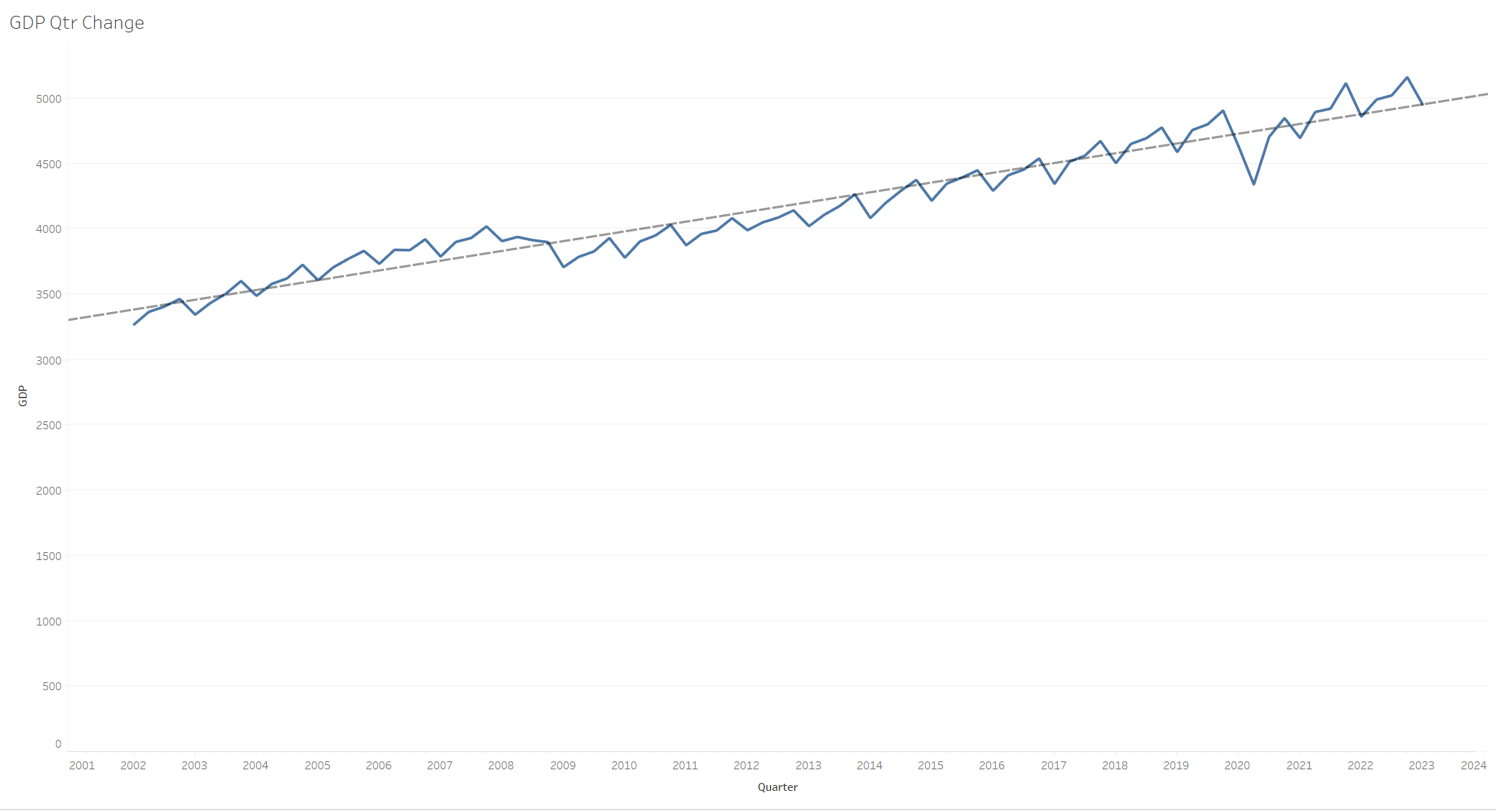

Retail Sales Trend:

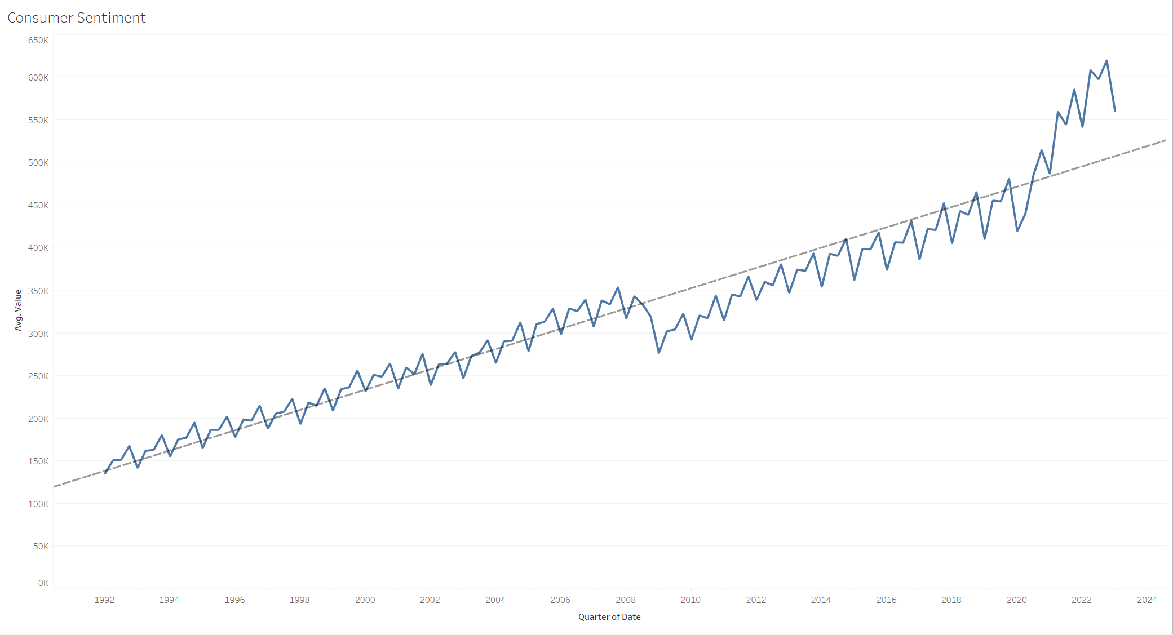

# Part 2: Cryptocurrencies

## Analysis

In this section, you should:

* Explain your data wrangling process (if any). Note down any important new columns you created in your BI tool and any steps you took to clean the data, change data types, etc.
* Explain your findings. Be sure to include answers to the questions:
  + What has happened in the cryptocurrency market in the last few years?
  + Has the pandemic had an effect? What was the general trend before 2020 and how has it changed from 2020 onwards?
  + What are the limitations of using this data to try to understand the cryptocurrency market?

## Duplicate columns were removed. Data type of opening and closing position was changed to currency.

## Despite some small fluctuations, Bitcoin transaction volume remained low at the beginning of pandemic. It saw a sudden boost by August 2022 when the impact of covid-19 began to decrease.

However, the exchange rate to USD experienced a completely opposite trend. It peaked at period when pandemic was the most serious and dropped to a relatively low position when it ceased. It’s hard to give an explanation by only looking at 2 factors. But a possible reason is that people started to sell off cryptocurrency when phasing out of Covid-19. There can be further insight if there’s data before and after Covid.

## Supporting evidence

Add any charts here that support your analysis of Part 2 (or include them directly in the Analysis section).

